## Customer Requirements Speciﬁcation

SAG_ML

**ـــــــــــــــــــــــــــــــــــــــــــــــــــــــــــــــــــــــــــــــــــــــــــــــــــــــــــــــــــــــــــــــــــــــــــــــــــــــــــــــــــــــــــــــــــــــــــــــــــــــــــــــــــــــــــــــــــــــــــــــــــــــ**

**Table of Contents**

Document Status 1

Document History 1

Reference Document 2

Project Description 3

# Document Status:

| **Name** | PO_ٍSAG_CRS_ML |
| --- | --- |
| **Version** | V1.0 |
| **Status** | propsed |
| **Author** | aya |
| **Date** | [27-9-2022] |

# Document History:

| **Version** | **Author** | **Date** | **Change** |
| --- | --- | --- | --- |
| 1.0 | Aya | [27-9-2022] | * Initial Creation * Add definition * Add features * Add Key elements * Add System Context * Add CRS Requirements |

# Reference Document:

| **Ref.number** | **Doc.Name** | **Version** | **Status** |
| --- | --- | --- | --- |
| 1 | PO_SAG_CR_ML | V1.1 | Released |

# Project Description:

## Definition:

The project is intended to help the blind using computer vision to help him to identify different things around him and NLP to interact with the user using voice commands.

## Features:

* Object detection
* Face recognition
* Activity recognition
* Text recognition
* Speech recognition

## Key Elements:

* Identify objects around the user.
* determine the distance between objects and the person
* Recognizing text including handwritten on different objects (book, paper, sign, …)
* Recognizing people determined by user
* Speech recognition to activate different features and the assistant
* Voice authentication

## **object detection**

## System Context:

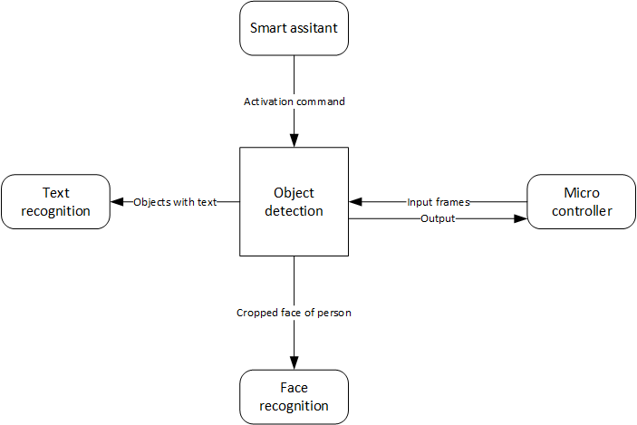

## CRS Requirements:

| **Req_ID** | Req_PO_SAG_CRS_ML_***001***-V1.0 | **Covers** | PO_SAG_CR_ML_001-V1.1 |
| --- | --- | --- | --- |
| **Description** | input frames are preprocessed | | |
| **Test type** |  | | |

| **Req_ID** | Req_PO_SAG_CRS_ML_***002***-V1.0 | **Covers** | PO_SAG_CR_ML_001-V1.1 |
| --- | --- | --- | --- |
| **Description** | frames are processed to identify objects within the frame | | |

| **Info_ID** | Info_PO_SAG_CRS_ML_***001***-V1.0 | **Covers** | Req_PO_SAG_CRS_ML_***002***-V1.0 |
| --- | --- | --- | --- |
| **Description** | multi-label classification and object localization | | |

| **Req_ID** | Req_PO_SAG_CRS_ML_***003***-V1.0 | **Covers** | PO_SAG_CR_ML_001-V1.1 |
| --- | --- | --- | --- |
| **Description** | output detected objects | | |

| **Info_ID** | Info_PO_SAG_CRS_ML_***002***-V1.0 | **Covers** | Req_PO_SAG_CRS_ML_***003***-V1.0 |
| --- | --- | --- | --- |
| **Description** | the size of data required for training is about 200GB | | |

| **Req_ID** | Req_PO_SAG_CRS_ML_***004***-V1.0 | **Covers** | PO_SAG_CR_ML_002-V1.0 |
| --- | --- | --- | --- |
| **Description** |  | | |

## **image captioning**

## System Context:

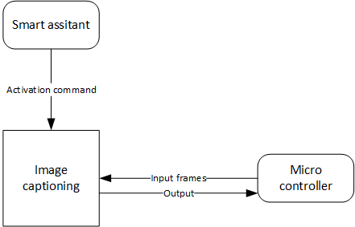

## CRS Requirements:

| **Req_ID** | Req_PO_SAG_CRS_ML_***005***-V1.0 | **Covers** | PO_SAG_CR_ML_003-V1.1 |
| --- | --- | --- | --- |
| **Description** | input frames are preprocessed | | |

| **Req_ID** | Req_PO_SAG_CRS_ML_***006***-V1.0 | **Covers** | PO_SAG_CR_ML_003-V1.1 |
| --- | --- | --- | --- |
| **Description** | frames are processed to identify actions within the frame | | |

| **Req_ID** | Req_PO_SAG_CRS_ML_***007***-V1.0 | **Covers** | PO_SAG_CR_ML_003-V1.1 |
| --- | --- | --- | --- |
| **Description** | output detected actions | | |

## **Text recognition**

## System Context:

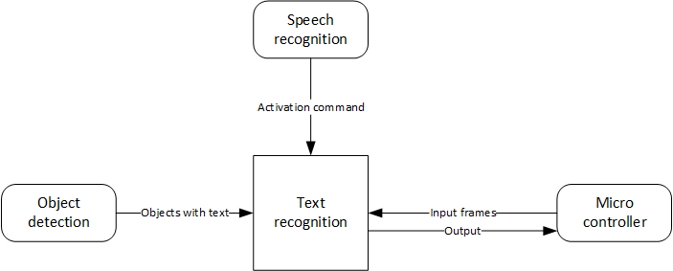

## CRS Requirements:

| **Req_ID** | Req_PO_SAG_CRS_ML_***008***-V1.0 | **Covers** | PO_SAG_CR_ML_004-V1.1 |
| --- | --- | --- | --- |
| **Description** | input frames are preprocessed to suit the model | | |

| **Req_ID** | Req_PO_SAG_CRS_ML_***009***-V1.0 | **Covers** | PO_SAG_CR_ML_004-V1.1 |
| --- | --- | --- | --- |
| **Description** | frames are processed to identify letters within the frame | | |

| **Req_ID** | Req_PO_SAG_CRS_ML_***010***-V1.0 | **Covers** | PO_SAG_CR_ML_004-V1.1 |
| --- | --- | --- | --- |
| **Description** | output detected text | | |

## 

## 

## 

## 

## 

## 

## **Face recognition**

## System Context:

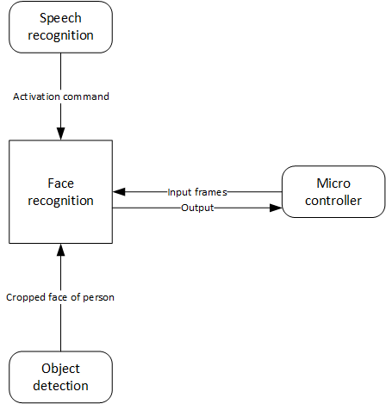

## CRS Requirements:

| **Req_ID** | Req_PO_SAG_CRS_ML_***011***-V1.0 | **Covers** | PO_SAG_CR_ML_005-V1.1 |
| --- | --- | --- | --- |
| **Description** | face is cropped from the frame and the passed to the model | | |

| **Req_ID** | Req_PO_SAG_CRS_ML_***012***-V1.0 | **Covers** | PO_SAG_CR_ML_005-V1.1 |
| --- | --- | --- | --- |
| **Description** | the model outputs the name of the person | | |

## **Speech recognition**

## System Context:

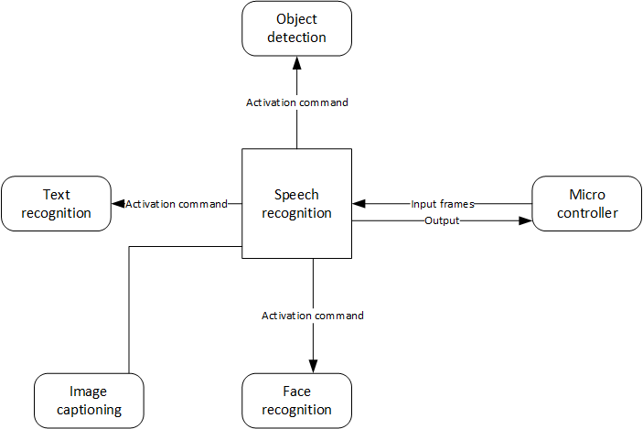

## CRS Requirements:

| **Req_ID** | Req_PO_SAG_CRS_ML_***013***-V1.0 | **Covers** | PO_SAG_CR_ML_006-V1.1 |
| --- | --- | --- | --- |
| **Description** | input is preprocessed to suit the mode | | |

| **Req_ID** | Req_PO_SAG_CRS_ML_***014***-V1.0 | **Covers** | PO_SAG_CR_ML_006-V1.1 |
| --- | --- | --- | --- |
| **Description** | The input is processed to recognize the commands of the user | | |

note: clarify trigger word or ignore it

| **Req_ID** | Req_PO_SAG_CRS_ML_***015***-V1.0 | **Covers** | PO_SAG_CR_ML_006-V1.1 |
| --- | --- | --- | --- |
| **Description** | the model outputs the action required or ask him again if not clear | | |

## **Voice authentication**

## System Context:

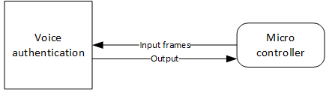

## CRS Requirements:

| **Req_ID** | Req_PO_SAG_CRS_ML_***016***-V1.0 | **Covers** | PO_SAG_CR_ML_007-V1.1 |
| --- | --- | --- | --- |
| **Description** | input is preprocessed to suit the mode | | |

| **Req_ID** | Req_PO_SAG_CRS_ML_***017***-V1.0 | **Covers** | PO_SAG_CR_ML_007-V1.0 |
| --- | --- | --- | --- |
| **Description** | model processes the input to determine whether the one giving commands is the authenticated user or not | | |

| **Req_ID** | Req_PO_SAG_CRS_ML_***018***-V1.0 | **Covers** | PO_SAG_CR_ML_007-V1.0 |
| --- | --- | --- | --- |
| **Description** | the model lets the user use the glasses or ask him to try again | | |